|  |  |  |
| --- | --- | --- |
| USACE CAD-BIM Technology Center **USACE** | ERDC | |
|
| *Master Guide Documentation* US Army Corps of Engineers Building Information Modeling Templates for Revit Templates based on the 2016 Autodesk Revit Software | |
|
| Master Guide : Template v3.0 Beta | October 2016 |
|
|  | |
|
| Author: David Johnson, ERDC, CAD/BIM Tech Center, Danny Griffin , USACE Mobile District, Hai Le, USACE Mobile District, Kevin J. Russ, USACE Sacramento District, Structural Template Lead, Carl Mudd and David Dawson  Special Thanks to contributions made by: Mobile, Sacramento, Fort Worth, Louisville Districts and Autodesk. | |
|

Contents

US Army Corps of Engineers Building Information Modeling Templates for Revit 1

Overview 3

Browser and View Organization 3

View Types: 4

View Naming 4

Working Views 4

Documentation Views 4

Coordination Views 5

View Filters 5

Legends 5

Schedules 5

NCS Symbols 6

Annotation/Dimensions 6

Sheets 6

Starting View 7

Sheet Grid 7

Families 9

Linestyles 9

References: 10

Appendix A: Annotation Symbols and the NCS 5.0 11

General Symbols: 11

View Title - Viewports: 11

Appendix B: Shared Parameters 16

Project Parameters 16

Sheet Parameters 18

Common Parameters: 21

# Overview

The intent of this guide for the templates is to provide a framework to facilitate architectural design using Revit Building Information Modeling software. These templates were developed based on Revit Architecture 2016.

This guide is NOT intended to be a Revit tutorial, but rather assumes that the user has a sufficient level of proficiency to comprehend the template descriptions outlined in this guide.

# Browser and View Organization

The default browser setting in the template (USACE Discipline) is organized by:

* *Discipline*
* *View Purpose*
* *Family and Type*
* *sorted by Associated Level.*

There are no predefined sub-disciplines in the architectural template.

Pre-defined view purposes are WORK (working views), and DOC (documentation). View purpose is defined as a project parameter and the uppercase abbreviation is also appended to the end of the view names to facilitate user recognition of the views. It should be noted that the classification of “Coordination” is an internal Revit type that is equivalent to the discipline – this value is set in the “View” “Discipline” parameter.

|  |  |  |
| --- | --- | --- |
| **Browser View Type** | **Grouping** | **Filter** |
| all | Default | <None> |
| Discipline_USACE | Group by:   * Discipline * View Purpose * Family & Type Sort by: * Associated Level | <None> |
| Not on Sheets_USACE | Group by:   * Family and Type * Then by: <None> * Then by: <None> Sort by: * View Name, Ascending | Filter by: Sheet Name = <None> |
| USACE View Purpose | Group By:   * Discipline (all characters) * View Purpose (all characters) * Family and Type Sort By: * Associated Level | <None> |

# View Purpose:

To separate the purposes of the Views and make creating the Sheets simpler, separate “View Purposes” have been created for Working Views (where the main modeling is done) the Documentation Views (where the Views set up for placing on sheets to for the official model Documents), Presentation Views (for required or accessory presentation Views) and Coordination Views (used to coordinate between the different disciplines). Each view that is created will have an attribute for “View Purpose” (under the “Other” Group of parameters).

List of View Purposes that is in the current template:

|  |  |  |
| --- | --- | --- |
| **View Purpose** Classifications | View Name Extension |  |
| * *1 Working* | *_WORK* |  |
| * *2 Analysis* | *_ ANAL* |  |
| * *4 Documentation* | *_DOC* |  |
| * *5 Presentation* | *_PRES* |  |
| * *6 Export* | *_EXP* |  |

# View Naming

Naming of views is to follow the standard set in the template and is divided into categories by: Floor Level_View Type_Region(use all if building not divided)_Function(depends on view purpose)_View Purpose

* Floor Number
  + View Type
    - Region
      * View Purpose
* Example A: 02_Floor Plan_East_Dimensions_DOC
* Example B: 00_North and South Elevations_All_Framing_WORK
* Example C: 03_Mechanical Plan_West_HW Piping_ANAL

# Working Views

This set of Views are for the main design and layout of the building. These views are not intended for the final documents and are used to support the modeling process (although a View Purpose may be changed to a Documentation view). There are two site Views (***Site_Plan*** and ***Site_Plan_True_North***). The True North View is set with the Orientation of True North. The user should change the orientation of the building to the actual orientation of the project in this view. The correct location coordinates should also be set in this view.

Note *: Change to new template version: View Template parameter is not set for the Working Views because of the locking of view graphics of views that are assigned a View Template.*

# Documentation Views

These views are finished and are intended to be placed on sheets. Documentation Views may contain scope box views for larger projects. Appropriate visibility and/or filter settings are applied to display only relevant categories and objects. These may need to be adjusted for specific needs.

There may be additional standards required by the owner or organization that is responsible for review of documentation. These should be followed in lieu of these standards.

# View Filters

View Filters are used for many views to limit the information and graphically define specific elements of the view (examples: Life Safety plans , natural gas lines, water lines, …)

Tip: Note that the view filters list in Revit cannot be sorted. They are listed in the order they were created.

***Note: For all USACE Projects, CAD and BIM requirements that are part of the work contract supersede these standards and settings.***

# Legends

The “Legends” View section contains legends that will need to be changed based on the specific project type and requirements. The “*ABBREVIATIONS*” legend uses a sample set of abbreviations that are derived from the National CAD Standards/Uniform Design System 5.0 list. The “*Legend, Building Summary and General Notes*” sections will need to be changed for the specific design and project requirements. The “*KEY PLAN*” legend contains the building outline legend view that can be applied to multiple sheets.

# Schedules

A set of USACE Schedules has been created based on typical USACE requirements and are labeled with a prefix “USACE “. These are set up for standard USACE documents for producing final sheets. There is a USACE schedule that has been created for Doors, Windows, Wall and Finishes. There are also additional schedules that may be used for quality control, reference or for documentation. These schedules are noted with a “Z-“. To assist with Quality Assurance and Control there may be some additional schedules labeled “*Z-QAQC*”. (Refer to Appendix “E” for more information on program schedule.) The “*Z-Sheet Information List*” list contains the drawing sheets that are in the project and the information (parameters) that is in each sheet. This schedule can be used to check that the record for drawing responsibility has been added to each sheet (“Designed By”, “Drawn By”, “Checked By”….), the proper building ID assigned and sheet revision information is listed. “*Z-View List*” schedule contains most parameter settings for the sheet such as the Family and Type (Elevation, Floor Plan, Section), View Name, Scale Value, assigned discipline, phase and View Purpose.

# NCS Symbols

Symbols (families) have been added, modified to comply with the current release of the National CAD Standards version 5. Refer to Appendix “A” for examples of the symbols used in the project.

Annotation/Dimensions

USACE fonts have been added that are based upon the National CAD Standards 6.0. For dimensions there are two types of dimensions that are set up: one contains arrows and the other contains slashes, both of which are acceptable in the National CAD Standards. There may be additional standards required by the owner or organization that is responsible for review of documentation. These shall be followed in lieu of these standards.

# Sheets

A sheet labeled “*0 – US**ACE Revit Starting View*” has been created as the initial opening sheet for the project. The sheet contains general project information and uses that are linked into the Project Information Attributes (accessed under the “Manage” tab, ”Project Information” icon). Additional user instructions may be contained on this sheet. (Refer to Appendix “B” on shared parameters for details.)

There is a cover sheet numbered G-001 that may be used that contains labels linked to the Project Information. Items such as “Project Name”, “Owner”, “Project Status”, “Solicitation” and “Contract Number” will automatically be filled in on the sheet.

The main body of the sheet set has been set up to assist with the documentation of the model. Use of this sheet set, titles and numbering may necessitate modification because of varying model conditions or as required by contract requirements.

There are sheet attributes that can be used for making a custom sheet order to manually control the order of sheets to be exported. There is also a checkbox for the sheet attribute “Appears in Sheet List” that can control whether the sheet appears in a sheet schedule (this is a default Revit parameter).

# Starting View

The opening sheet is set up to allow users/managers to add notifications or messages to people involved with the project. There are also additional standards notes for the template to assist users (Browser Organization, View Naming, Sheet Naming, Sheet Publishing Order, project information). The Project Information section is linked to the Project Information parameters in the “Project Properties” Menu (accessed from the Manage tab on the menu bar). Project information is to be filled out here and then the information will be populated to the sheets.

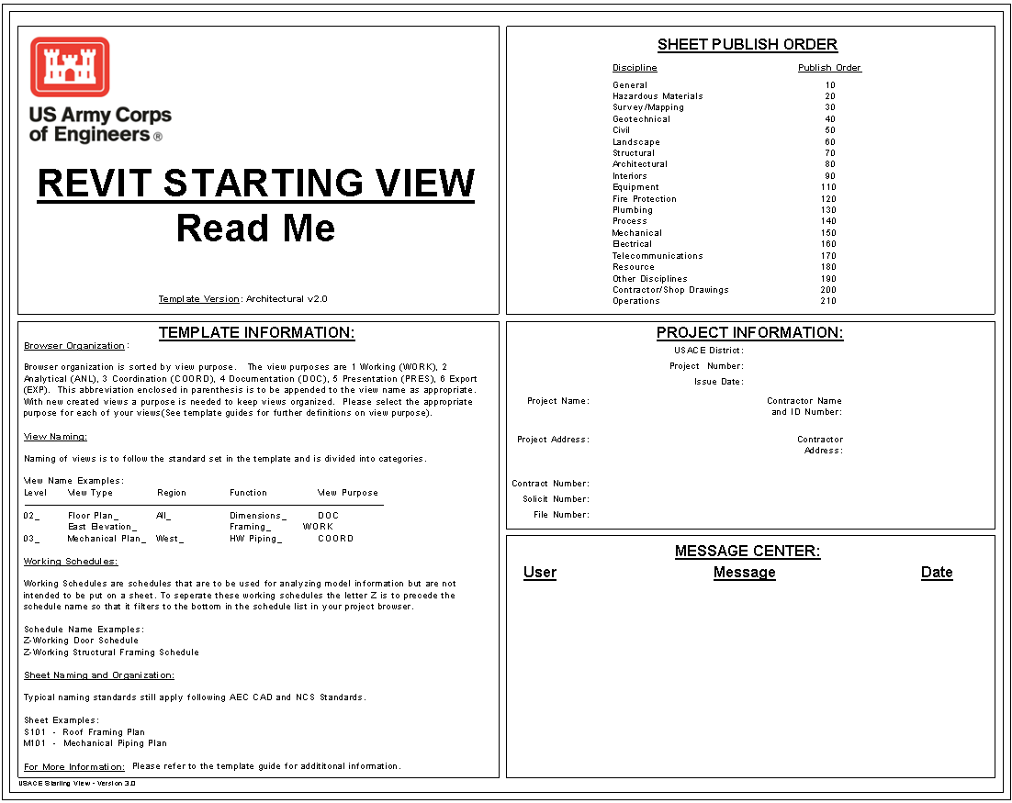

# Families

List of Families used in the Architectural Template.

|  |  |  |  |
| --- | --- | --- | --- |
| **FAMILIES** | | | |
| **Family Type** | **Family Name** | **Source** | **NCS 5** |
| **Compliant** |
| **Annotation** | | | |
|  | ANSI D_22x34_Border_USACE | USACE | **YES** |
|  | Door Tag NCS | USACE | **YES** |
|  | Egress Path Tag_USACE | USACE | **YES** |
|  | Elevation Exterior Mark Body_Circle_NCS | USACE | **YES** |
|  | Elevation Exterior Mark Pointer_Circle_NCS | USACE | **YES** |
|  | Elevation Interior Mark Body_Circle_NCS | USACE | **YES** |
|  | Elevation Interior Mark Pointer_Circle_NCS | USACE | **YES** |
|  | Elevation Mark Pointer_Circle_NCS_1/4 | USACE | **YES** |
|  | Graphic Scales_Arch AEC6_Arch | USACE | **YES** |
|  | Graphic Scales_Civil AEC6_Civil | USACE | **YES** |
|  | Grid Head - Circle_NCS | USACE | **YES** |
|  | Keynote DEMO | USACE | **YES** |
|  | Keynote ELEVS | USACE | **YES** |
|  | Level Head - Circle_NCS | USACE | **YES** |
|  | North Arrow_NCS | USACE | **YES** |
|  | Project Starting View_USACE | USACE | **YES** |
|  | Room Tag_NCS | USACE | **YES** |
|  | Section Head - Filled 5/8" NCS | USACE | **YES** |
|  | Section Tail - Filled_NCS | USACE | **YES** |
|  | Sheet Keynote - Hexagon_USACE | USACE | **YES** |
|  | Section Tail - Filled_NCS5 | USACE | **YES** |
|  | Sheet Keynote - Hexagon_USACE | USACE | **YES** |
|  | View Title_NCS | USACE | **YES** |
|  | Window Tag_NCS | USACE | **YES** |
|  |  |  |  |
| **Generic Model** | | | |
|  | USACE_Egress Path_GenModel | **USACE** | **NA** |
| **Specialty Equipment** |  |  |  |
|  | Sign_ Interior_USACE | USACE | NA |

### Linestyles

**USACE Air Barrier** Line Style “USACE Air Barrier” created to identify required building “Air Barrier” limits.

* + 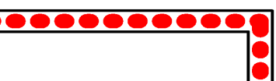Not an intelligent object:
    - Manually placed.
    - Does not automatically change when Wall changes types.

# References:

The location for download of the templates is: <https://cadbim.usace.army.mil/BIM>. Links to documentation, Q&A and a review form is also available on this site.

Please direct questions or comments about the Templates to : [David M. Johnson](mailto:david.m.johnson1@us.army.mil?subject=USACE%20Revit%20Template-%20Version%202.0)

# Appendix A: Annotation Symbols and the NCS 5.0

### General Symbols:

The symbols shown below are based upon the requirements of the NCS 5.0. Images are not to scale.

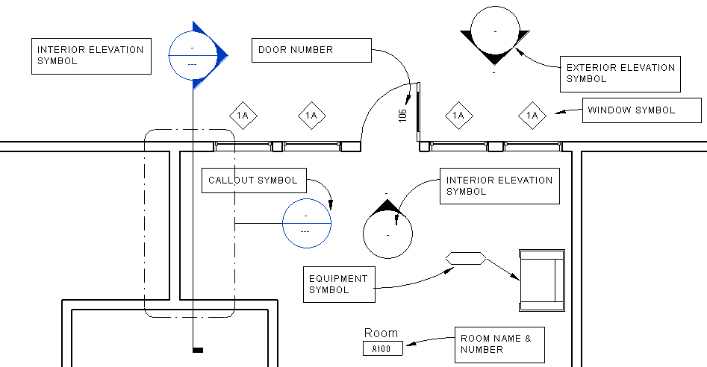

**Floor Plan Symbols**

|  |  |
| --- | --- |
|  |  |
|  | USACE Wall Section:  Added Section marker that hides the objects beneath it. |

**Revision to Section Marker- opaque marker hides objects in background.**

### View Title - Viewports:

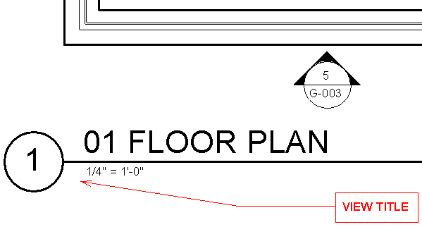

|  |  |  |  |
| --- | --- | --- | --- |
| **ADDED FAMILIES:** | | | |
| **View Title_NCS.rfa** | The default View Title placed in a sheet will always be the “View Title_NCS” Family. | | |
|  |  | | |
| **Viewports in the Template** | | | |
| **View Title - NCS** | |  |  |
|  | | Title: | *View Title NCS5* |
|  | | Show Title: | *Yes* |
|  | | Show Extension Line: | *Checked* |
| **View Title - Reference Sheet** | | Title: ¼”  Other text: 3/32” |  |
|  | | Title*:* | *View Title_NCS : VIEW TITLE - Reference Number* |
|  | | Show Title: | *Yes* |
|  | | Show Extension Line: | *Checked* |
| **View Title- No Number** | |  |  |
|  | | Title: | *View Title_NCS : VIEW TITLE - No Number* |
|  | | Show Title: | *Yes* |
|  | | Show Extension Line: | *Checked* |
| **View-No Title, Number or Line** | |  |  |
|  | | Title: | *View Title_NCS : VIEW - No Title/Number* |
|  | | Show Title: | *No* |
|  | | Show Extension Line: | *NA* |
| **View** **Title- No Number or Line** | |  |  |
|  | | Title: | View Title_NCS : VIEW TITLE - No Number |
|  | | Show Title: | *Yes* |
|  | | Show Extension Line: | *unChecked* |
|  | |  |  |
| **View Title- Default** | |  |  |
|  | | Title*:* | *View Title_NCS : View Title - NSC* |
|  | | Show Title: | *Yes* |
|  | | Show Extension Line: | *Checked* |
| **DELETED FAMILY** | |  |  |
| **View Title** | | OOTB : View Title | Removed the View Title family to prevent use of non-NCS standard symbol. |

## Symbol Component Families

### Section Marker

* **Family:** *Section*
* **Name:** *Section USACE Building Section*
* **Callout Tag:** *USACE Callout Head w 1/8" Corner Radius*
  + **Callout Head:** *Callout Head - w-Dash_NCS5 : Callout Head NCS*
  + **Corner Radius :** *1.8”*
* **Section Tag:** *Section Head - Filled, Section Tail – NCS*
  + **Section Head :** *Section Head - Filled, Section Tail – NCS*
  + **Section Tail :** *Section Tail - Filled_NCS5 : 1/16" x 1/8"*

### Exterior Elevation Symbol:

* **Family :** *System Family: Elevation*
* **Type :** *USACE Exterior Building Elevation*
* **Type Parameters:**
  + ***Graphics***:
    - Elevation Tag USACE Exterior Elevation
      * ***Type Properties***
        + **Family:** System Family: Elevation Tag
        + **Type:** USACE Exterior Elevation
        + **Graphics:**

Elevation Mark : *Elevation Mark Body_Circle Exterior_NCS5 : Detail Number and View Name*

* + - Callout Tag *USACE Callout Head w 1/8” Corner Radius NCS50*
      * ***Type Properties***
        + **Family:** *System Family: Callout Tag*
        + **Type:** *USACE Callout Head w 1/8" Corner Radius NCS50*
        + **Graphics:**

Callout Head : *Callout Head - w-Dash_NCS5 : Callout Head NCS*

Corner Radius : *1/8”*

* + - Reference Label *Sim*
  + ***Identity Data***
    - View Template Applied to new views None

### Interior Elevation Symbol:

* **Family :** *System Family: Elevation*
* **Type :** *USACE Interior Building Elevation*
* **Type Parameters:**
  + ***Graphics***:
    - Elevation Tag *USACE Interior Elevation 5/8"*
      * ***Type Properties***
        + **Family:** *System Family: Elevation Tag*
        + **Type:** *USACE Interior Elevation 5/8”*
        + **Graphics:**

Elevation Mark : *Elevation Mark Body_Circle_NCS5 : Filled Arrow and View Name*

* + - Callout Tag *USACE Callout Head w 1/8" Corner Radius*
      * ***Type Properties***
        + **Family:** *System Family: Callout Tag*
        + **Type:** *USACE Callout Head w 1/8" Corner Radius NCS50*
        + **Graphics:**

Callout Head : *USACE Callout Head w 1/8" Corner Radius NCS50*

Corner Radius : *1/8”*

* + - Reference Label *Sim*
  + ***Identity Data***

### View Template Applied to new views

* 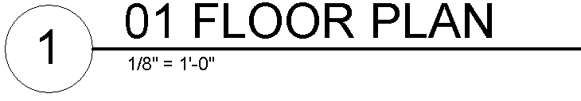**Family :** *System Family: Viewport*
* **Type :** ***View Title - NCS***
* **Type Parameters:**
  + ***Graphics***:
    - Title: View Title - Reference Sheet_NCS5 : View Title
    - Show Title : Yes
    - Show Extension Line : Yes
    - Line Weight: 6
* 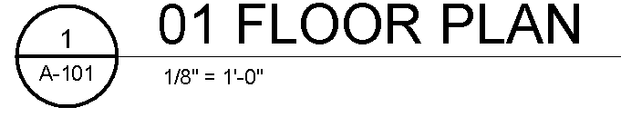**Family :** *System Family: Viewport*
* **Type :** ***View Title - Reference Sheet***
* **Type Parameters:**
  + ***Graphics***:
    - Title: View Title - Reference Sheet_NCS5 : View Title
    - Show Title : Yes
    - Show Extension Line : Yes
    - Line Weight: 6
* **Family :** *System Family: Viewport*
* 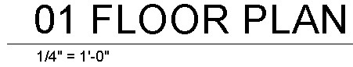**Type :** ***View Title- No Number***
* **Type Parameters:**
  + ***Graphics***:
    - Title: View Title_NCS : VIEW TITLE - No Number
    - Show Title : Yes
    - Show Extension Line : Checked
    - Line Weight: 6
* 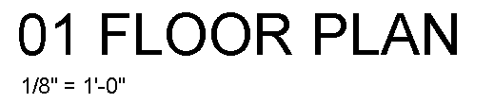**Family :** *System Family: Viewport*
* **Type :** ***View – No Title, Number or Line***
* **Type Parameters:**
  + ***Graphics***:
    - Title: View Title_NCS : VIEW TITLE - No Number
    - Show Title : No
    - Show Extension Line : NA
    - Line Weight: 6
* **Family :** *System Family: Viewport*
* **Type :** ***View No Title***
* **Type Parameters:**
  + ***Graphics***:
    - Title: View Title_NCS : View Title - NSC
    - Show Title : Yes
    - Show Extension Line : Checked
    - Line Weight: 6

## Room Name & Number:

* **Family :** *Room Tag_NCS5*
* **Type :** *Room Tag with Number*
* **Type:**  *Room Tag with Area*
* **Type**: *Room Tag with Volume*

## Name: Door Tag:

* **Family :** *Door Tag NCS*
* **Type :** *Door Tag 7/16”*

## Window Tag:

* **Family :** *Window Tag_NCS*
* **Type :** *Door Tag NCS*
* **Type:** *Door Tag NCS Extended*

## Equipment Symbol:

* **Family :** *Furniture Tag_NCS5*
* **Type :** *Boxed*

## Callout Symbol:

* **Family :** *Callout Heads*
* **Type :** *Callout Head NCS*
* **Type Parameters:**
  + **Graphics –** 
    - **Callout Tag :** *USACE Callout Head w 1/8" Corner Radius NCS50*

## Level Head Symbol:

* **Family :** *System Family: Level*
* **Type :** *NCS5 1/4" Head*
* **Type Parameters:**
  + **Graphics**
    - **Symbol :** *Level Head - Circle_NCS5 : Level Head - Circle NCS5*

# Appendix B: Border Sheets:

There has been a change in the Border sheets to correspond with anticipated changes that USACE will be doing for the official standard border sheet. The USACE completed border sheet is not yet approved but should be very close to the revised Revit Border sheet included in the template.

### Text Box:

Some items have changed in the drawing sheet text box as compared with the previous border sheet. The font sizes have been made more consistent (generally 3/32”). The “*ISSUE DATE*” is the project issue date (“*Project Issue Date*” parameter on the “Project Parameters” dialog box. The previous “File Name” and “File Number” parameters have been changed to *Optional* parameters to be used by the designer/project manager. The “**File Number**” box title is now controlled by the “*Alternate_Info_Title 1*” parameter, the field parameter is the “*Alternate_Info 2*”. The “**File Name**” box is set by the parameter “*Alternate_Info_Title 2*” and the field is “*Alternate_Info 2*”.

***Note:*** To simplify the Project and Sheet titles several previous attributes have been deleted. To create a multiline project title for example, the user can create a multiline text title in notepad and copy and paste into the Revit project information dialog box. Revit does not allow the user to directly put carriage returns in the text box.

The sheet title uses the Revit parameter “*Sheet Name*” for the top line and will not accept any carriage returns. A second line has been created called “*SHEET_TITLE_1*”. This parameter does accept additional lines if external text is copied and pasted into the text box for the parameter using the dialog box.

There are additional options that may be selected for a sheet that are type parameters (affects all sheets in the project) or instance parameters (affects only the single sheet).

### Revision Box:

For the revision box, the category “APPR” has been eliminated. There are only seven lines of revisions that will be visible since that will be a USACE standard requirement. The font is set at 3/32” to match the standards. For more revisions than the eight shown, Revit will keep the top 8 most current revisions in the list but will still keep the previous ones in memory as part of the project information.

### Additional Items:

In the Project Information dialog box, there is an additional Attribute for “Project Status” that will be shown on the bottom right of the sheet.

There are additional parameters for printing the “File Path” and “Plot Date” that can be turned on if needed.

For additional production notes that are two parameters for each sheet: “Production Data 3” & “Production Data 4”. These are instance parameters applying to each sheet.

There are also Type parameters for “File Plot Information” that allows the user to turn on or turn off this text for all text for sheets. There is a Type parameter (“Production Notes Visibility”) allowing the user to turn on or off the Production Data information (both lines) for all sheets.

# Appendix C: Shared Parameters

## Project Parameters

There are separate Shared parameter lists: one for commonly shared parameters (such as used for Border Sheets and one for each discipline). The Common shared parameter list contains groups that relate to several different types of elements: Project, border sheets, cover sheet. There are also discipline specific parameters for Objects: egress, area, doors, rooms, walls, egress and windows.

### Project Parameters on Border sheet

The mapping below shows the Revit Project Parameter dialog box with the location of the parameters in the list and the corresponding parameter in the title block of the Border sheet. These Project level parameters will automatically be assigned to every sheet in the project (including new sheets). A change to an attribute in the dialog box represents a change to the text in every border sheet on the project.

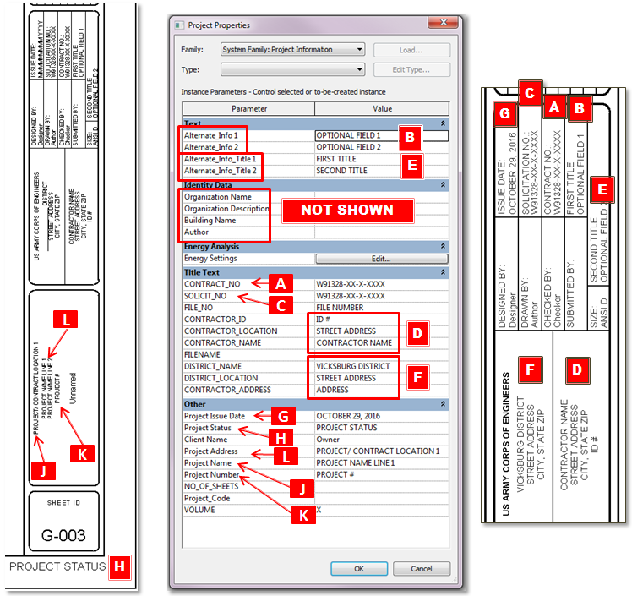

### Sheet Parameters on Border sheet

The mapping below shows the Revit Sheet Parameter dialog box with the location of the parameters in the list and the corresponding Labels on the sheet.

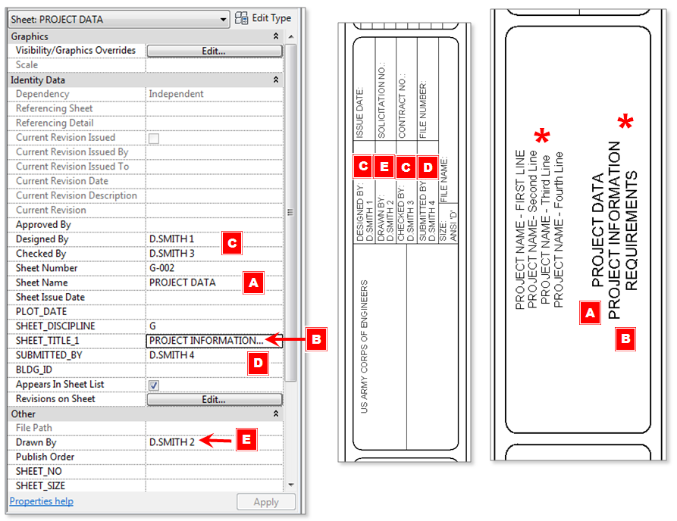

*

***NOTE:*** *See information below for multiline text.*

### Multiline Text for Parameters

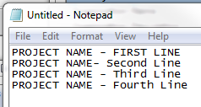The “*Project Name*” and the “*SHEET_TITLE_1*” parameters allow users to create multiline text with carriage returns embedded. To create Multiline Text parameters:

* Open Sheet View Dialog Box
* Create Multiline text in Notepad
* Use “hard returns” to divide lines
* Copy and Paste the text from Notepad into the Parameter information in the Dialog Box
* There are two lines maximum available to use.

## Sheet Parameters Visibility Settings:

There are both Instance and Type Parameter Sheet Information that applies to all sheets to set visibility of certain sheet information. Type parameter changes will affect label box Visibility for all sheets, instance parameter changes only affect the Visibility of the label box for the selected sheet.

|  |  |  |
| --- | --- | --- |
| **Visibility Settings : Project Level (Type parameter)** | **Default**  **Value** | **K**  **C**  **A**  **D**  **E**  **B** |
| Standard USACE Contract parameters  **A** | **On** |
| Alternate Contract parameters  **B** | **Off** |
| Visibility of Sheet number ? Of ?? Parameter.  **C** | **Off** |
| Used for CAD Sheet name if required  **D** | **Off** |
| Contractor information: additional information  **E** | **On** |
| Project Status Visibility  **K** | **Off** |
| **Visibility Settings : Sheet Level (Instance parameter)**  **E** | **Default**  **Value** |  |
| Grid Visibility for detail sheets | **Off** | **F**  **E** |
|  | **Off** |
| Visibility of Building Identification  **F**  (used for multiple buildings in a single project, combined set of models, identify specific building)  Visibility Parameter: *Building_ID_Visibility*  Attribute Parameter: *BLDG_ID* | **Off** |
| **F** |
|  |

|  |  |  |  |
| --- | --- | --- | --- |
| USACE Contract parameters | Alt. Contract parameters | Project Status | Building ID ; Sheet # of ## |
| **G** | **H** | **K** | **E**  **F** |

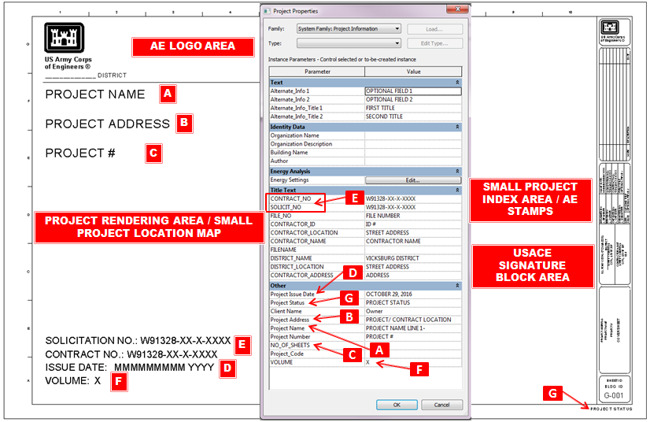

Shared parameters are built into the Project Information to link to the sheets and the cover sheet as shown in the illustration above for the Project Properties dialog box.

Sheet parameters are connected to sheet information and apply to the individual sheet.

Alternate categories may be used in place of the Solicitation Number and the Contract Number if these are not necessary.

There is a View attribute to identify the “View Purpose” for each view (Working, Documentation, Presentation, Coordination views).

## Common Shared Parameters:

USACE_sharedparameters_Common_v2.0.txt



|  |  |  |  |  |  |  |  |  |
| --- | --- | --- | --- | --- | --- | --- | --- | --- |
| **\*PARAM** | **GUID** | **NAME** | **DATATYPE** | **DATACATEGORY** | **GROUP** | **VISIBLE** | **USERMODIFIABLE** | **GROUP2** |
| PARAM | 02a8f20c-5a11-483a-88e7-70439cc53d79 | PLOT_DATE | TEXT |  | 7 | 1 | 1 | USACE_Sheet |
| PARAM | 97ab8c1e-0942-4520-b64d-9568dc7cad67 | Sheet_Type | TEXT |  | 7 | 1 | 1 | USACE_Sheet |
| PARAM | 020d1a2a-964b-4d08-bc6e-b0aed6ab2fb0 | SUBMITTED_BY | TEXT |  | 7 | 1 | 1 | USACE_Sheet |
| PARAM | 209cee37-c170-4709-b4ef-343ab00773f7 | SHEET_TITLE_1 | TEXT |  | 7 | 1 | 1 | USACE_Sheet |
| PARAM | d75b9067-67b1-4cc8-b738-7c659a90eeb7 | SHEET_SCALE | TEXT |  | 7 | 1 | 1 | USACE_Sheet |
| PARAM | 295adf67-de24-47a0-b7fb-888fd60724aa | SHEET_NO | INTEGER |  | 7 | 1 | 1 | USACE_Sheet |
| PARAM | d766a569-c8b4-4dca-bcd2-eeaa307f2abc | User_Defined | TEXT |  | 7 | 1 | 1 | USACE_Sheet |
| PARAM | 06c51081-d03f-4768-a590-b94417d81cd2 | BLDG_ID | TEXT |  | 7 | 1 | 1 | USACE_Sheet |
| PARAM | 638e0cad-f48d-4709-abf0-2fe38920ca31 | Production Data 4: | TEXT |  | 7 | 1 | 1 | USACE_Sheet |
| PARAM | 69ed19d2-02d7-4af2-8493-bb4669c61a0b | Production Data 3: | TEXT |  | 7 | 1 | 1 | USACE_Sheet |
| PARAM | 58f8f5d2-0c86-43ee-a0ce-b96f7d427866 | SHEET_SIZE | TEXT |  | 7 | 1 | 1 | USACE_Sheet |
| PARAM | 1616a8d5-d795-4112-97d8-2da1fc84d784 | Project Status Visibility | YESNO |  | 7 | 1 | 1 | USACE_Sheet |
| PARAM | b83c0ddd-414d-4524-ae31-3b1c4566e700 | Publish_Order | NUMBER |  | 7 | 1 | 1 | USACE_Sheet |
| PARAM | 5f6aedeb-0ca7-426e-9138-adbef1ce9e89 | SHEET_DISCIPLINE | TEXT |  | 7 | 1 | 1 | USACE_Sheet |
| PARAM | 28ea4ef0-bb85-4a12-954f-50709de812cd | Level_2_Designator | TEXT |  | 7 | 1 | 1 | USACE_Sheet |
| PARAM | 00ec2600-afe8-4262-a6d5-3764bd738552 | Alternate_Info 2 | TEXT |  | 8 | 1 | 1 | USACE_Project |
| PARAM | 88768e00-ab59-4ccd-89e5-0b23b6b05a81 | SOLICIT_NO | TEXT |  | 8 | 1 | 1 | USACE_Project |
| PARAM | 6d6e8a09-8993-43f4-8590-e43491f13d5d | FILE_NO | TEXT |  | 8 | 1 | 1 | USACE_Project |
| PARAM | c81c4b0d-7158-4b95-b98c-8a83b5c7d732 | Alternate_Info_Title 1 | TEXT |  | 8 | 1 | 1 | USACE_Project |
| PARAM | dc775a26-5d27-4abf-b55a-3106605cdc59 | CONTRACTOR_LOCATION | TEXT |  | 8 | 1 | 1 | USACE_Project |
| PARAM | 7121762a-c24d-4cfa-bd86-6d38cf4439bd | ISSUE_DATE | TEXT |  | 8 | 1 | 1 | USACE_Project |
| PARAM | 5495503f-0335-4d61-bcca-eb9daa555241 | Alternate_Info 1 | TEXT |  | 8 | 1 | 1 | USACE_Project |
| PARAM | bd95613f-d2c8-445b-a981-5b733c8bdafa | CONTRACTOR_NAME | TEXT |  | 8 | 1 | 1 | USACE_Project |
| PARAM | ac29b247-de72-4bb5-a297-4881c17774e5 | DISTRICT_LOCATION | TEXT |  | 8 | 1 | 1 | USACE_Project |
| PARAM | ab7a4b57-598a-41ab-b379-b5ac11ed4398 | CONTRACTOR_ID | TEXT |  | 8 | 1 | 1 | USACE_Project |
| PARAM | 1e764664-b0ca-4f73-a6e3-9d490326296e | Project_Location | TEXT |  | 8 | 1 | 1 | USACE_Project |
| PARAM | d49e9c6f-5668-4fc6-a192-5f7e8c2bb8c5 | DISTRICT_NAME | TEXT |  | 8 | 1 | 1 | USACE_Project |
| PARAM | 35f5efa8-743f-4655-aee7-5acbef068256 | CONTRACT_NO | TEXT |  | 8 | 1 | 1 | USACE_Project |
| PARAM | 852905eb-fe17-412d-995c-94417af6d61e | Project_Code | TEXT |  | 8 | 1 | 1 | USACE_Project |
| PARAM | 00b71af1-01e2-4dd2-8fb0-e5db6852c234 | FILENAME | TEXT |  | 8 | 1 | 1 | USACE_Project |
| PARAM | 1a10bdf4-75d7-491c-99dd-da3f343372e3 | Alternate_Info_Title 2 | TEXT |  | 8 | 1 | 1 | USACE_Project |
| PARAM | 8d81b968-cc64-4af7-8bd3-7043f8936ca3 | USACE_Template_Version | TEXT |  | 10 | 1 | 1 | USACE_Revit_Template |
| PARAM | a102f4b7-6285-4aa1-9da3-d33418b9a29e | USACE_Template_Date | TEXT |  | 10 | 1 | 1 | USACE_Revit_Template |

# Appendix D: Coordination of Template

Each template has been set up with the views places around a 200’ foot grid.

A square starting from the base Project Base Point/Survey point has been established as the modeling space and is consistent between the templates. This will provide a consistent starting environment for the models.

This also provides a positive starting point for the model.

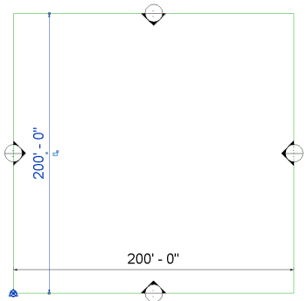

**SURVEY POINT**

**PROJECT BASE POINT**

# Appendix E: Method for submitting comments

Send email questions to :

[USACE Revit Template Team](mailto:USACE-Revit-Template-Team@erdc.dren.mil?subject=USACE%202016%20Revit%20Base%20Template%20v3.0%20Beta)

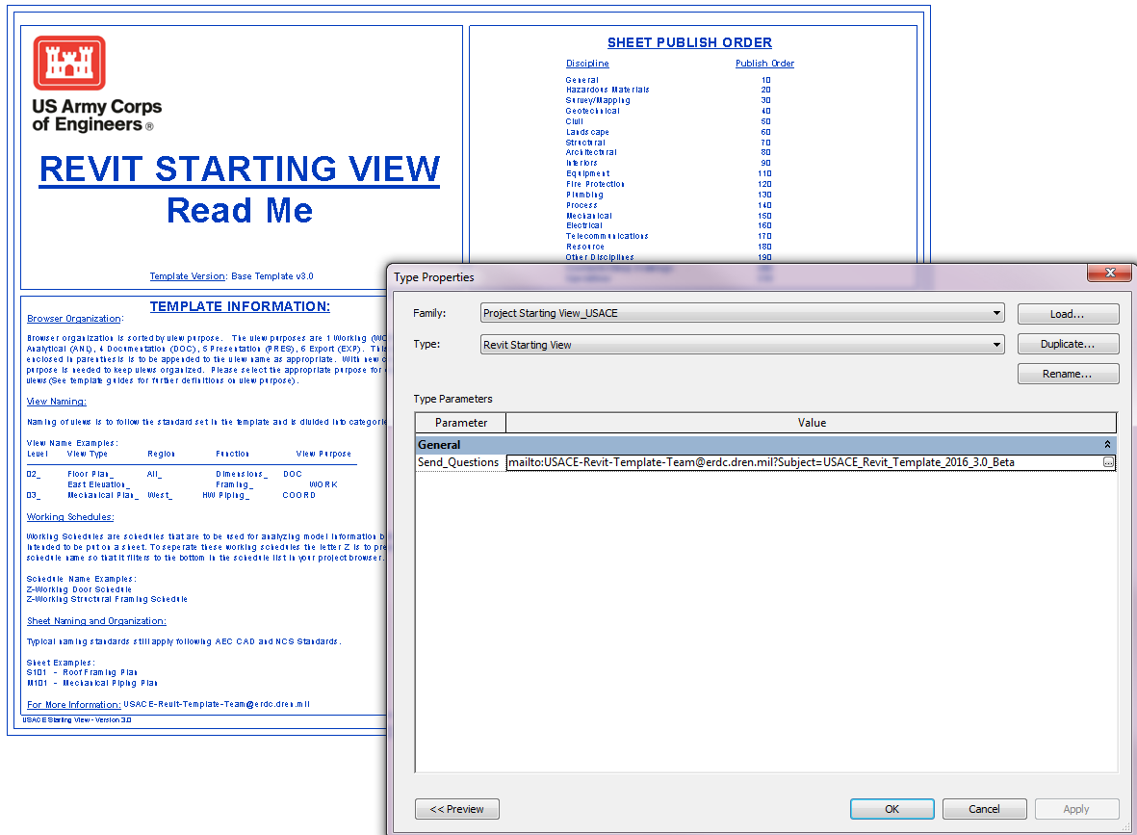

In the “USACE Revit Starting View” family, there is a URL parameter link for questions: “Send_Questions”. The email address is also shown in the instructions.

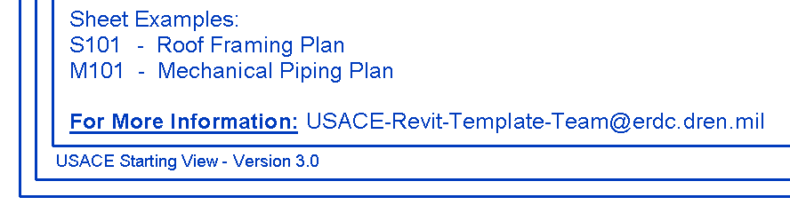

Alternate method:

For comments on the USACE Revit Templates, use the following ProjNet website to provide feedback to the development team. The Quick Add and Key Access allow users to log in to add comments about the specific template disciplines. New users will need to create an account (free) and can use the Quick Add key access to enter comments. There are separate key codes for accessing the individual disciplines.

Website: <https://www.projnet.org>

Help: <http://projnet.com/faqs.php>

To access the Discipline comment sites use the following **Quick Add** codes:

* Architecture v2.0 : 73GUSK DKXC3E
* Structure v2.0 : F62CG2 JKRXDG
* Mechanical v2.0 : 5F4H92 7N447Y
* Electrical v2.0 : XSQAK4 M4X48I

***Note****: For comments on common symbols or border sheets use the* ***architectural*** *discipline as the point of entry.*

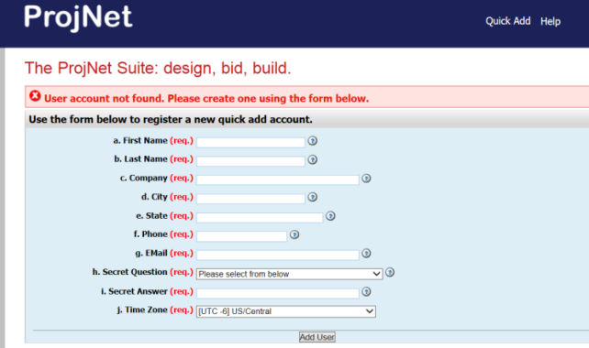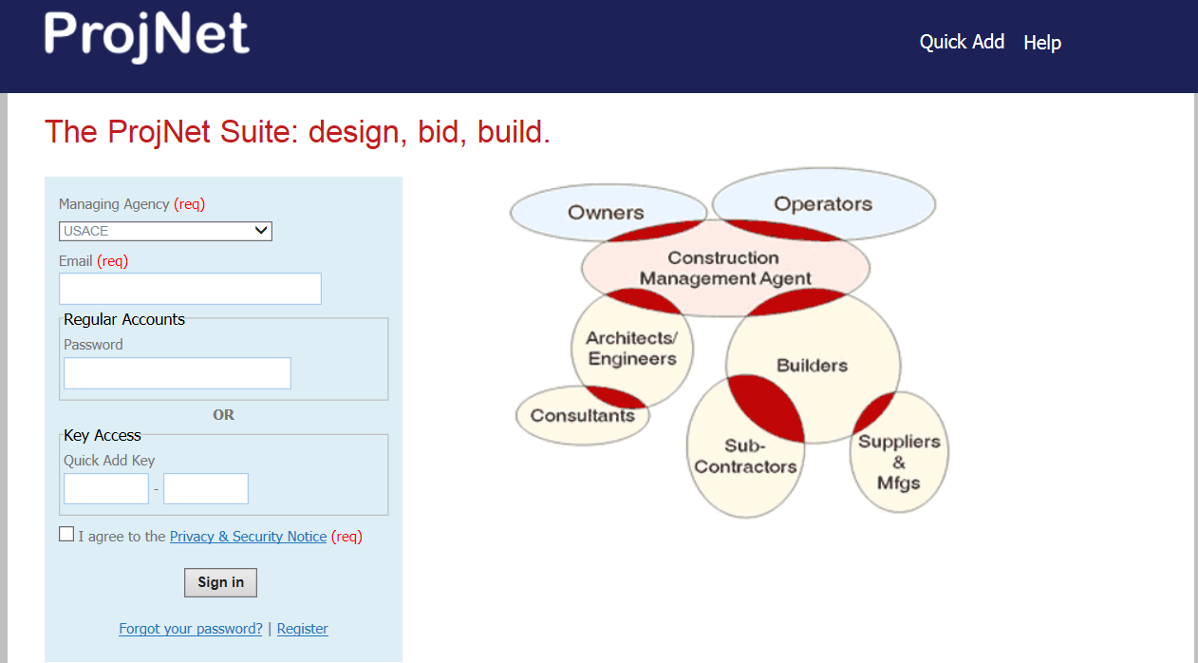

Complete the information in the input box with your *email* *address*, *Key Access* and Privacy statement agreement.

For new users that do not have an account set up you will need to register to get access to the ProjNet site for providing feedback.

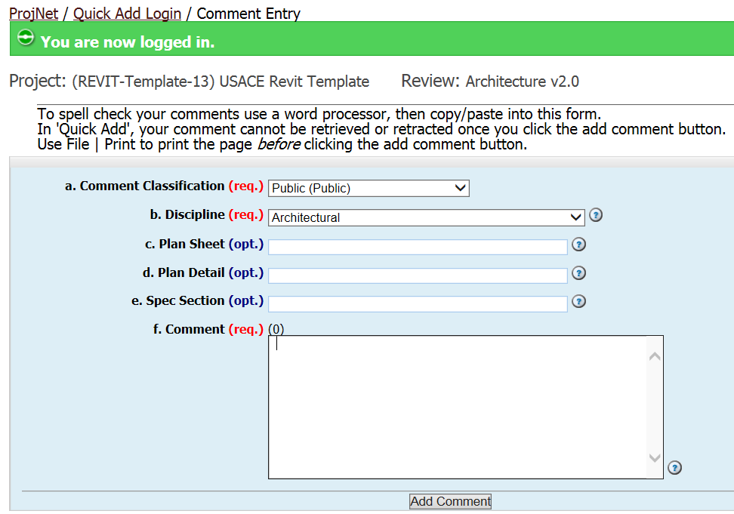

1. Comment Classification: Select the ***Public (Public)*** option
2. Discipline: Select Discipline (depending on what Quick Code was entered)
   1. Architectural
   2. Structural
   3. Mechanical
   4. Plumbing
   5. Electrical
3. Not Applicable
4. Not Applicable
5. Not Applicable
6. Comment: Add comments to this box concerning the template that you are reviewing.

# Appendix F: Change Notes

|  |  |  |  |  |
| --- | --- | --- | --- | --- |
| Change Notes | | | | |
| Seq | Changes Made | Category of Change | Effect | Purpose |
| 2016/Oct | Base template for creation of related discipline templates. | New template | Revision to previous template creation method. | Will be used as the basis for later discipline templates |
| 2016/Oct | New Border sheet (AEC 6.0 Standards) | Sheet |  | Meet AEC 6.0 Standards |
| 2016/Oct | New Cover sheet (AEC 6.0 Standards) | Sheet |  | Meet AEC 6.0 Standards |
| 2016/Oct | Revision of shared parameters for base template | Parameters |  |  |
| 2016/Oct | Removal of discipline specific items:  Schedules  Families  Legends |  |  |  |

**End of Document**